The University of Azad Jammu and Kashmir, Muzaffarabad


Course: Computer Network
Course Code: CS-2203
Roll No: 2024-SE-13
Lab: 5
Submitted To: Engr. Asma Javaid
Submitted By: Sughra Mumshad
Date: 31 March, 2026

Department Of Software Engineering

Switches Communication between the LAN:
Step1: Take two swiches to make LAN
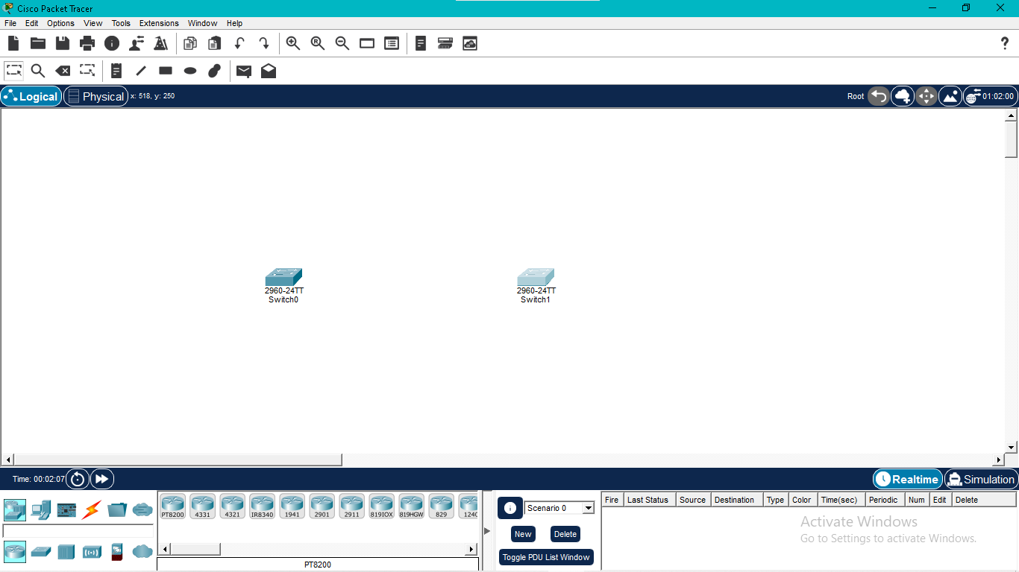
Step 2: Take Some Pcs Corresponding to switches

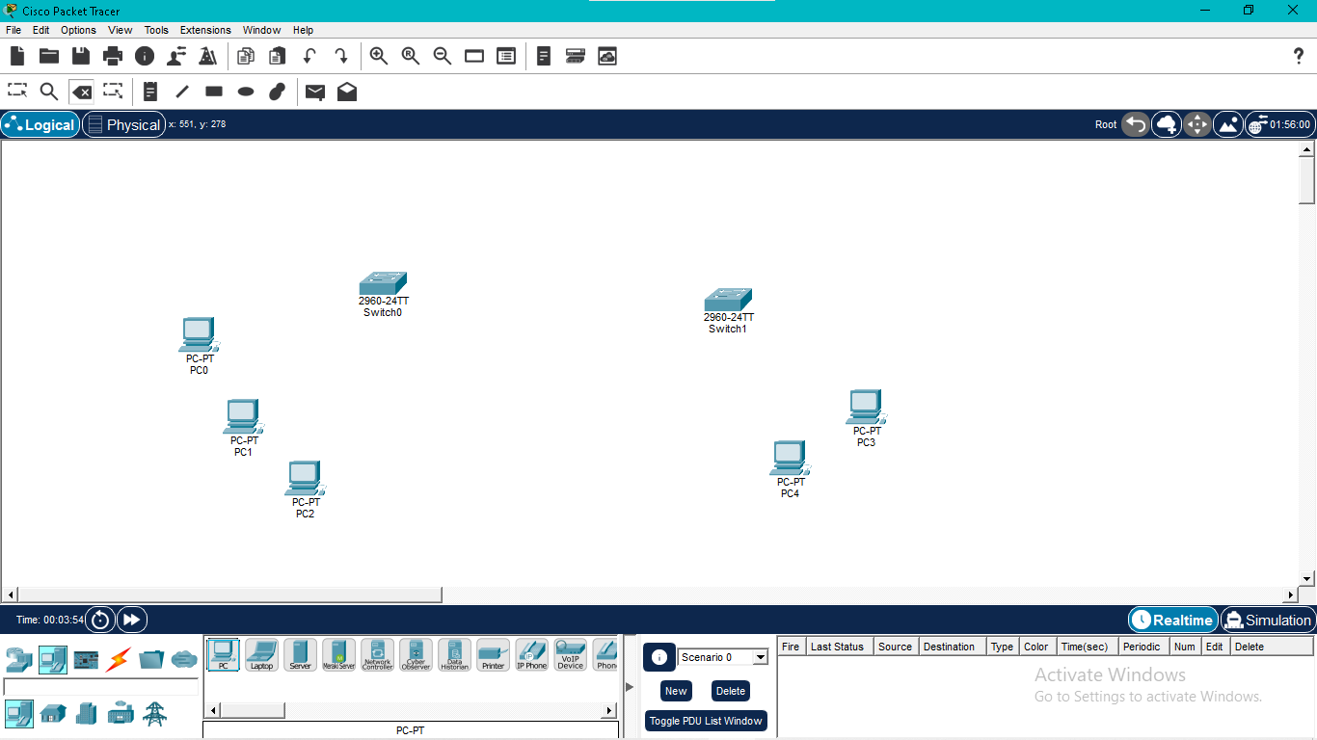
Step 3: Use Copper straight through Cable to connect pcs to switch 1 automatically
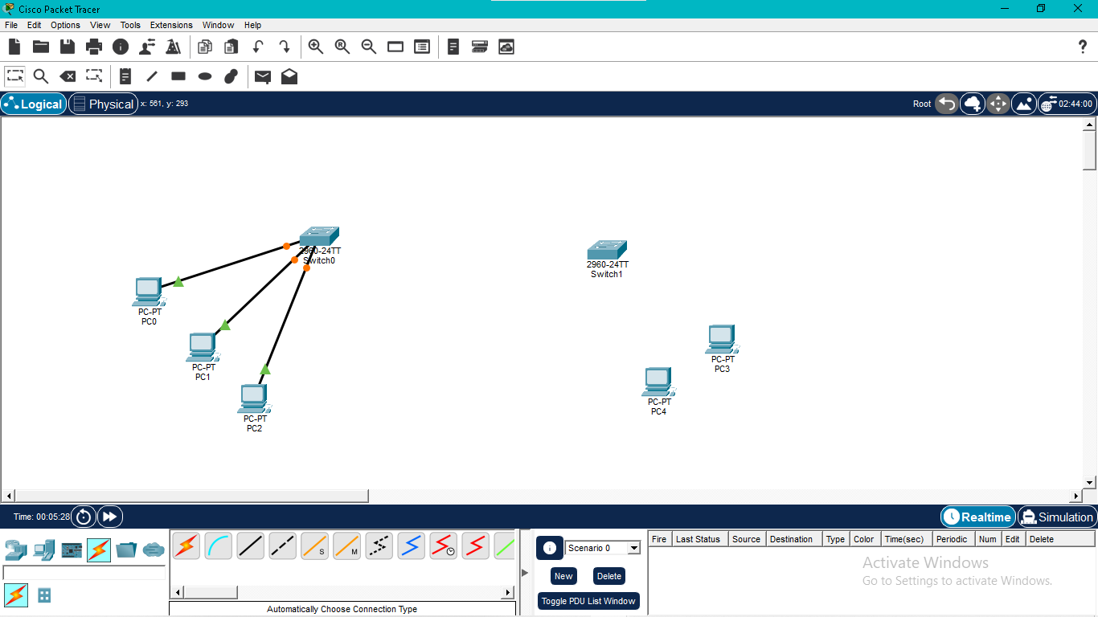
Step 4: Use same cable to connect pcs to switch 2 automatically
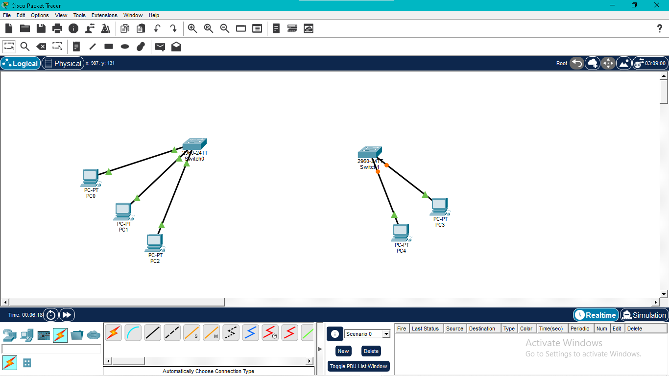

Step 5: Use Copper Cross Over Cable to connect switches

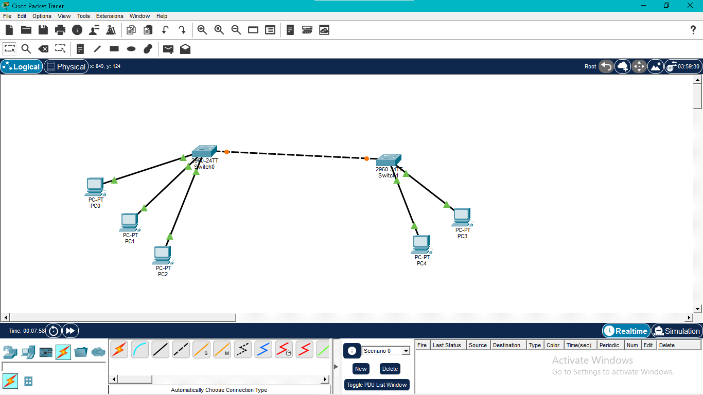
Step 6: Give IP addresses to all the switches
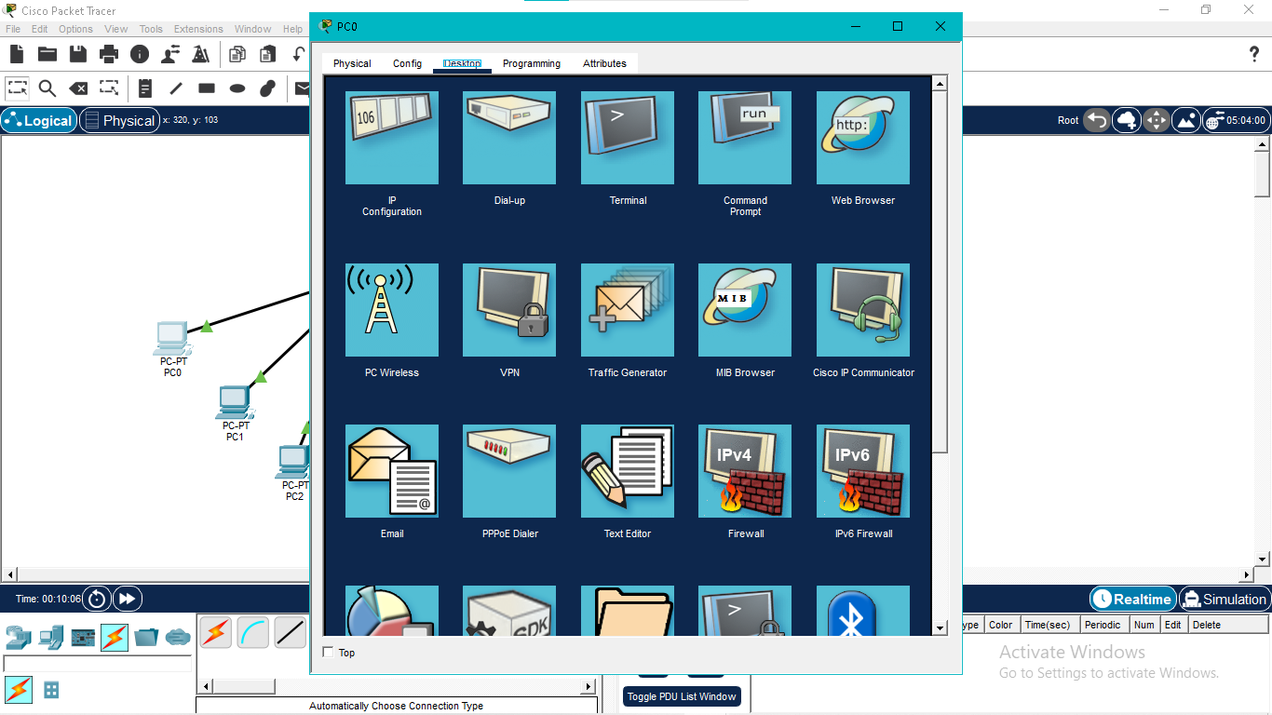

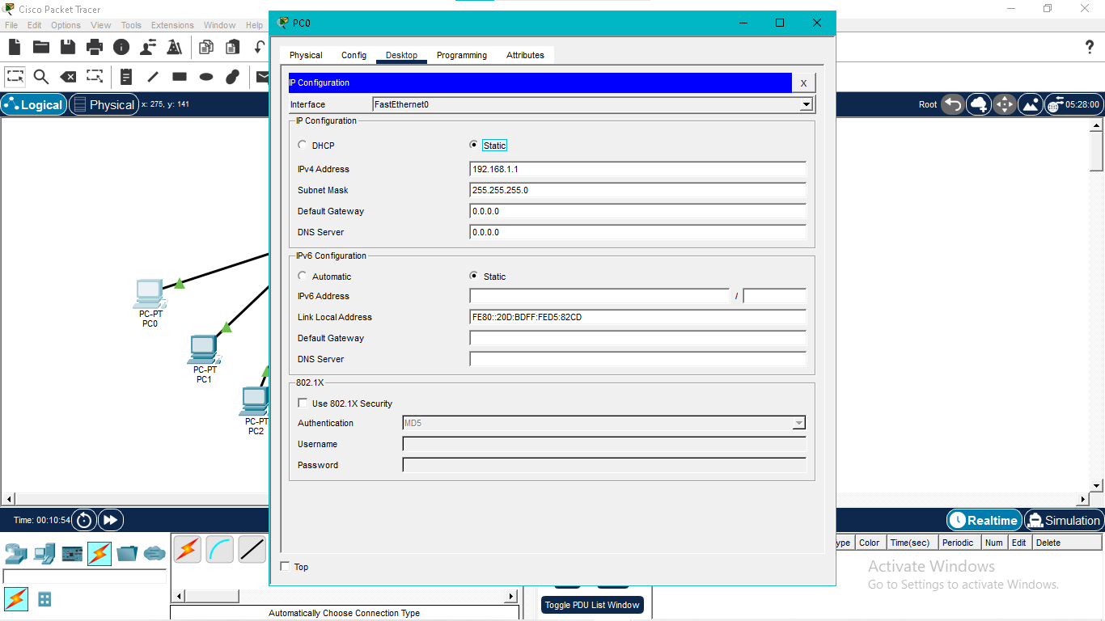

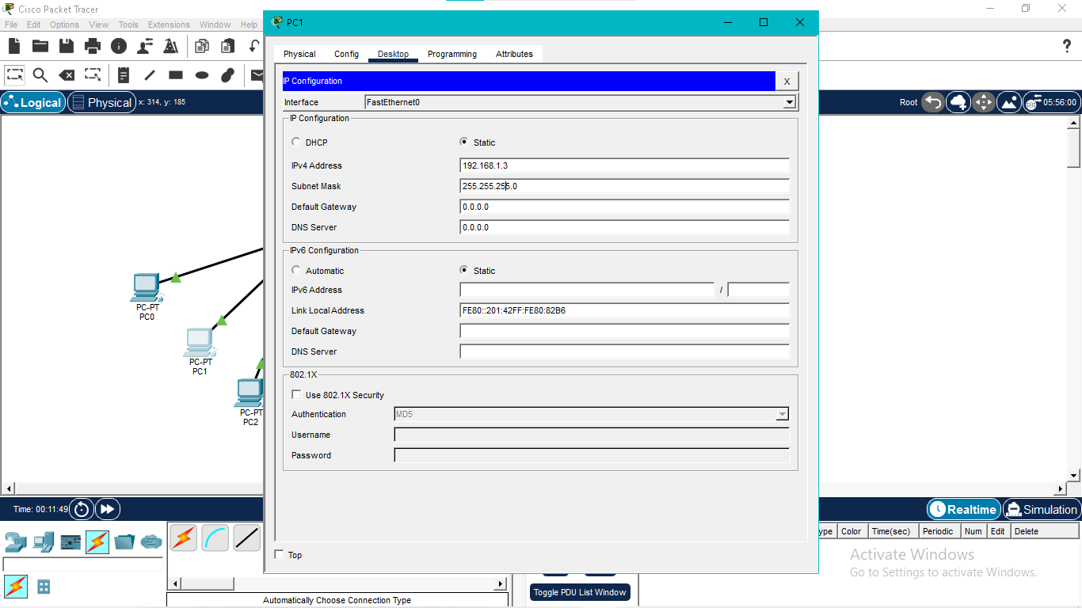
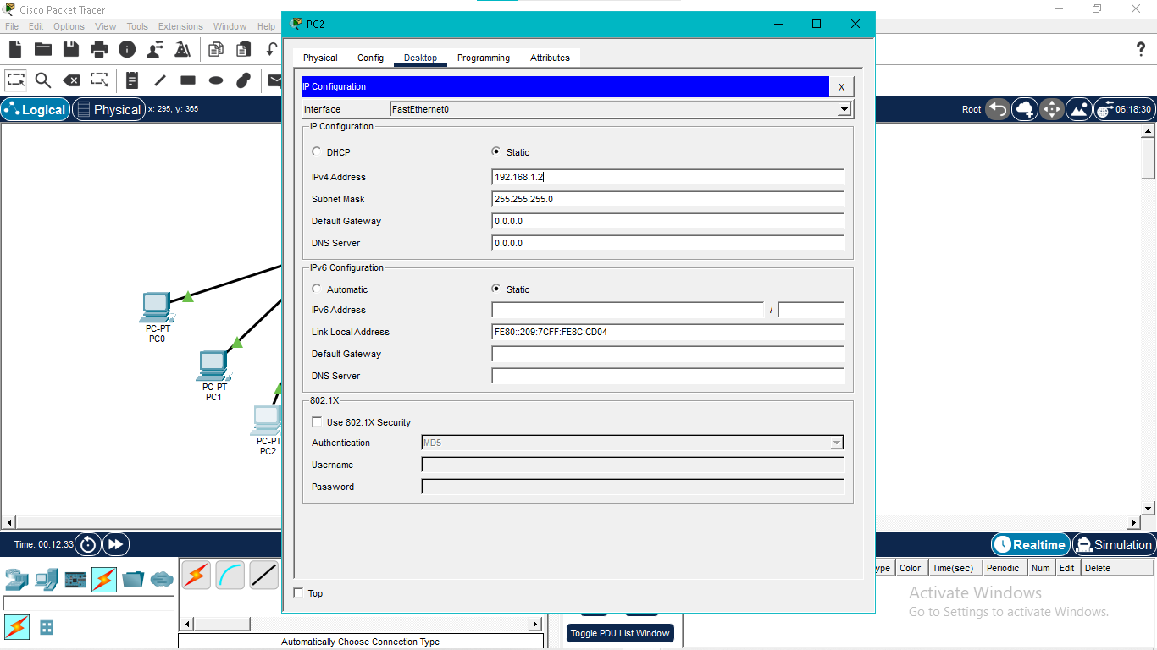

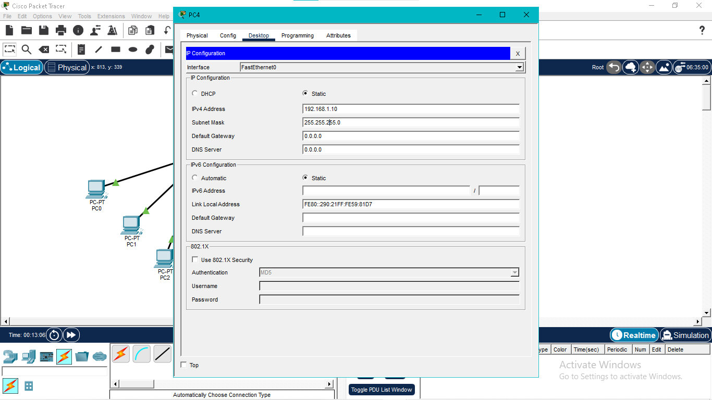

Step 7: Take Packet for transfer between pcs
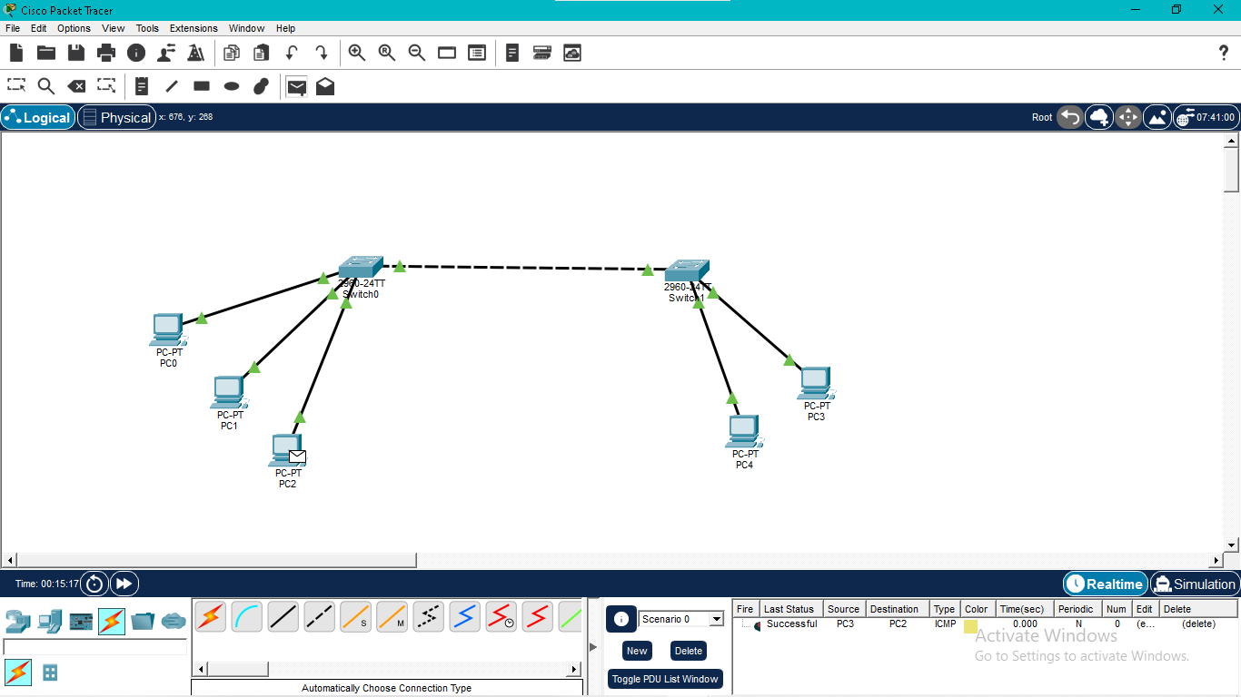
Step 8 : Check simulation
